**Proof By Pizza – ©David Acheson**

[David Acheson on Guitar _ Loughborough 2013](https://www.youtube.com/watch?v=jT6a-u46N1M)

[http://plus.maths. org/content/1089-and-all](http://plus.maths.org/content/1089-and-all)

Consider this series

1/4 + 1/16 + 1/64 + …

Which fraction is next in the series? How do you know?

Add up the first three terms. Give your answer as a fraction.

Add up the first four terms. Give your answer as a fraction.

If it were possible to add up all of the terms what might the total be? How do you know? ***Can you prove it?***

[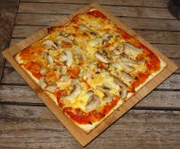](http://www.google.co.uk/url?sa=i&rct=j&q=square+pizza&source=images&cd=&cad=rja&uact=8&docid=ZUjuuCb69XNZeM&tbnid=_3Jy6ywv8PhQTM:&ved=0CAUQjRw&url=http://goodeating.scmp.com/restaurants/hong-kong/hong-kong-island/central/cafe-o&ei=jNkGVOLtEcTgaJ7OgWA&bvm=bv.74115972,d.d2s&psig=AFQjCNEWZKlG_6uUP1dqt4R0c6F3fZf8jg&ust=1409821404619241)

Imagine a very large square pizza.

I cut it into quarters.

I give you *and each of your two friends* one of the quarters.

I cut the fourth piece into 4 equal parts and repeat the process until we are left with tiny crumbs

How does this prove your result above?

This proof is the work of David Acheson – read 1089 for more inspiration.

